US Cellular
Talend Operational Support Guide for Information Management

Table of Contents
1. Introduction: 4
1.1 Overview: 4
2. Environments: 6
3. Source Code Inventory, Artifactory & Jenkins Details: 6
4. Normal Operating Procedure: 9
4.1 Monitoring: 9
4.2 Startup and Shutdown Procedure: 10
4.3 Application Maintenance: 11
5. User Access Management: 11
6. General Troubleshooting: 11
7. Appendix and Other Key Information: 13

Introduction:

Overview:
Talend is a data integration platform which is used to connect and manage various data sources including Enterprise Data Warehouse (EDW), Operational Data Store (ODS), Oracle Autonomous Data Warehouse (ASA) etc. It can also be used to perform various ETL, ELT and other DI tasks.
Here at USCC, we are using Talend tool for IS & Engineering Teams. Here is the product & functional architecture respectively for Talend 8.0:

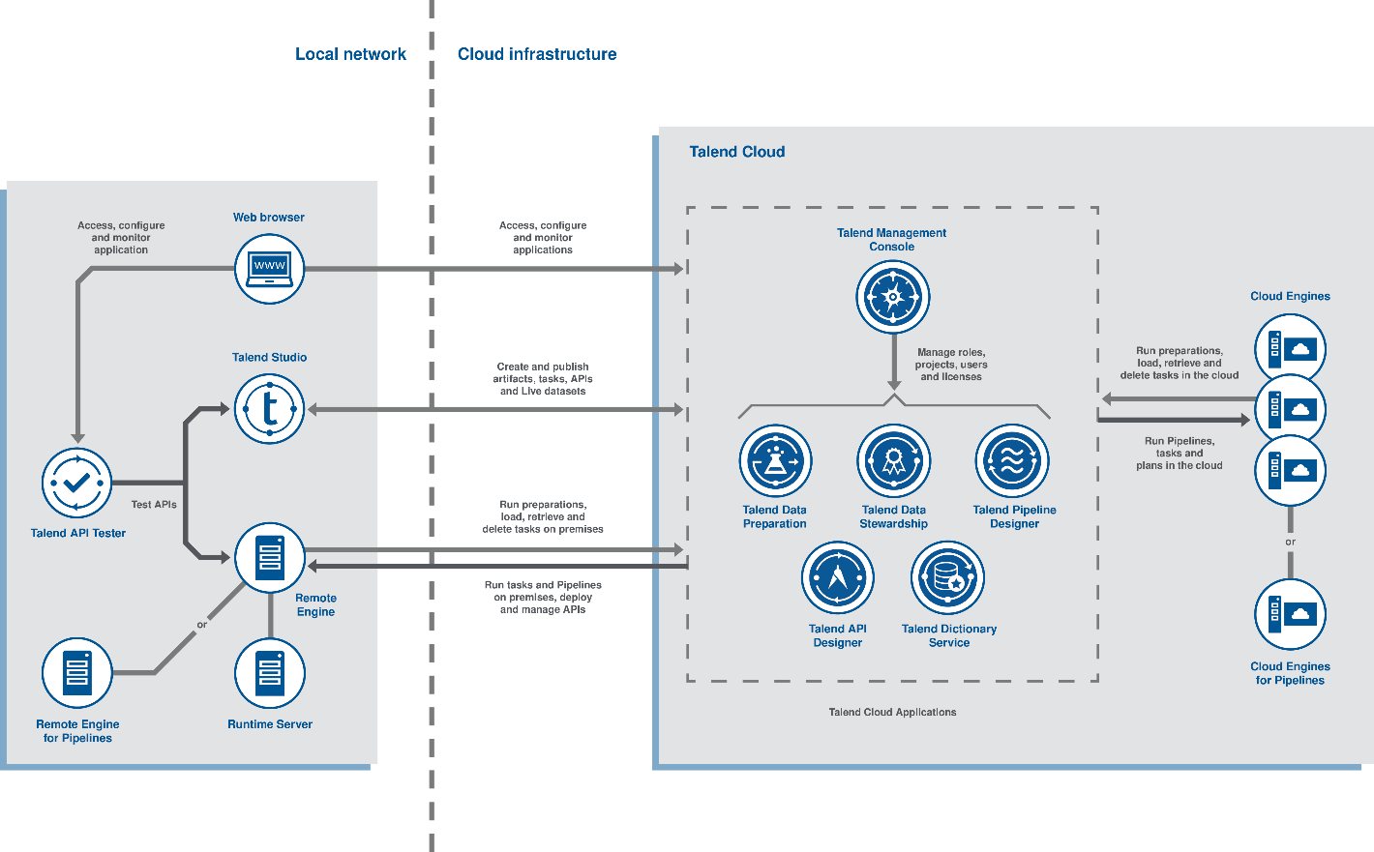
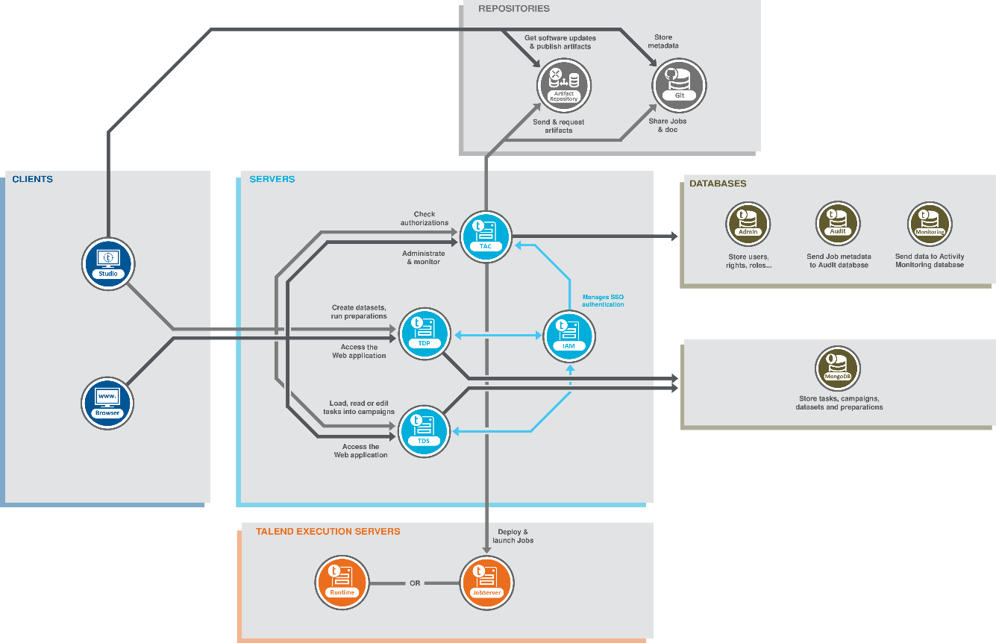

Below is the architectural diagram for the Talend Application at USCC:

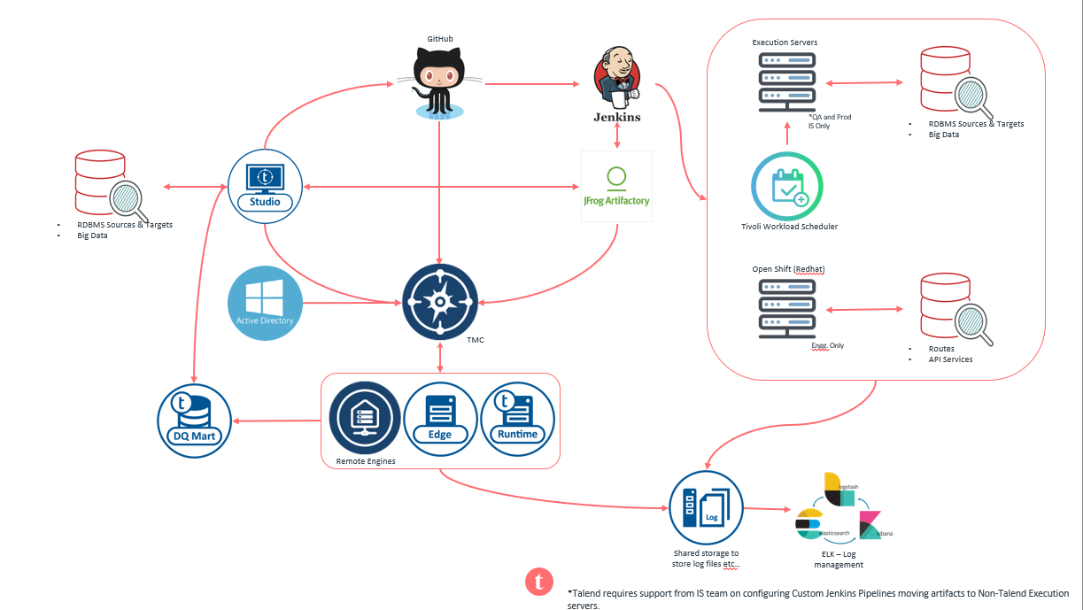

Environments:

This section describes the production environment in which the application executes, list of all Unix servers:
Servers for isdev:
- ilscha03-cem-dev-pre3.cem.uscc.com
- sdr01infa1
- sdr02infa1
Servers for Non-Prod for Engineering Team:
- sdr01job01
- sdr01esb01
- sdr01esb02

- sdr01esb03
- sdr01esb04
- sdr01amq01
- sdr01amq02
- sdr01elk01
Servers for Bill Prod:
- spr01esb01
- spr01esb02
Servers for Engineering DI:
- spr01job01
- spr01job02
- kpr01job01
- kpr01job02
- spr01esb03
- spr01esb04
Other Prod Servers:
- spr01elk01
- spr01amq01
- spr01amq02

Source Code Inventory, Artifactory & Jenkins Details:

We are using GitHub for the source code repository and JFrog to store the Artifacts from Talend Studio including the libraries, jars needed for the job build. Below are the screenshots and URL’s for the same:
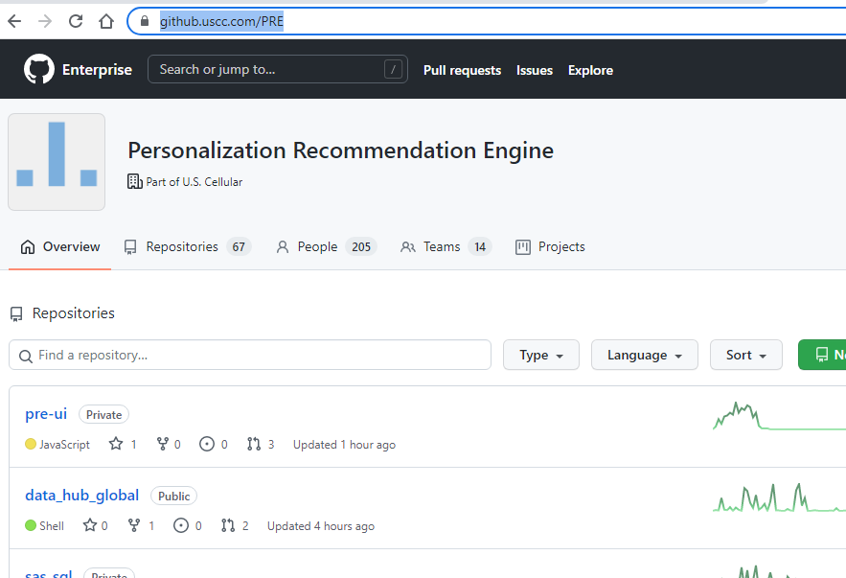

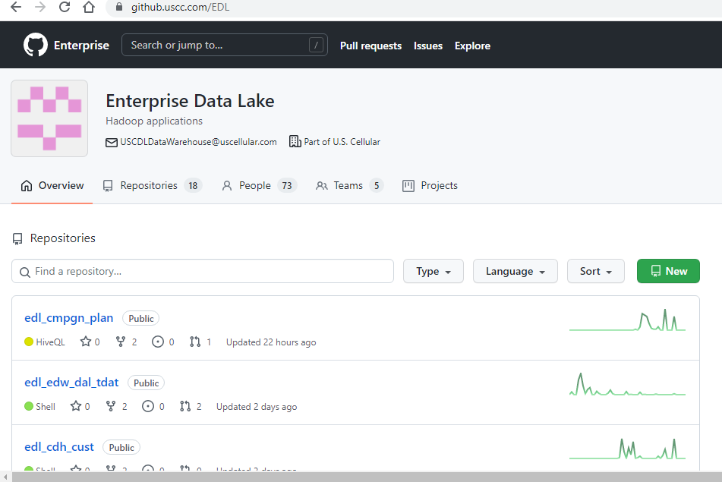

URL’s for GitHub:
- https://github.uscc.com/EDL
- https://github.uscc.com/PRE

Below is the Folder structure in Jenkins:

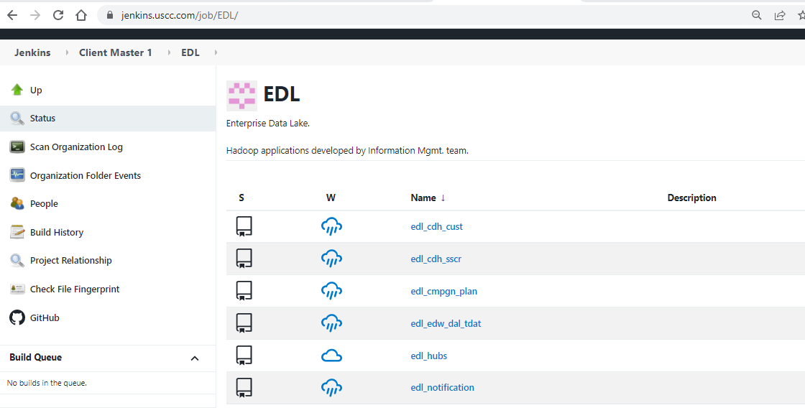

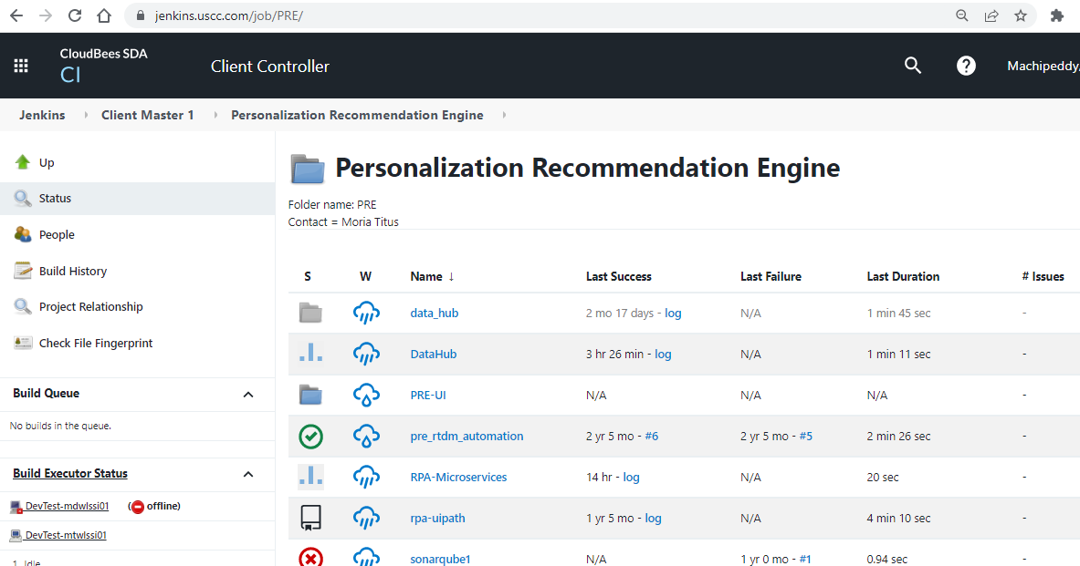

Jenkins URL’s are:
- https://jenkins.uscc.com/job/PRE/
- https://jenkins.uscc.com/job/EDL/

Below are the URL’s for Artifact Repository:

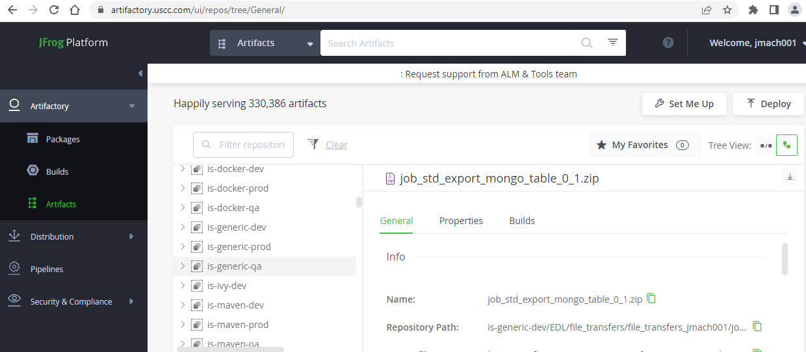
- https://artifactory.uscc.com/ui/repos/tree/General/is-generic-dev
- https://artifactory.uscc.com/ui/repos/tree/General/is-generic-qa
- https://artifactory.uscc.com/ui/repos/tree/General/is-generic-prod

Normal Operating Procedure:

Monitoring:

Nimsoft is the monitoring tool that we have in place for Talend applications. Below are the details on the metrics that is being monitored:
- Talend Remote Engine Process – Across all Talend Servers. If this process goes down, there should be an alert sent for the same.

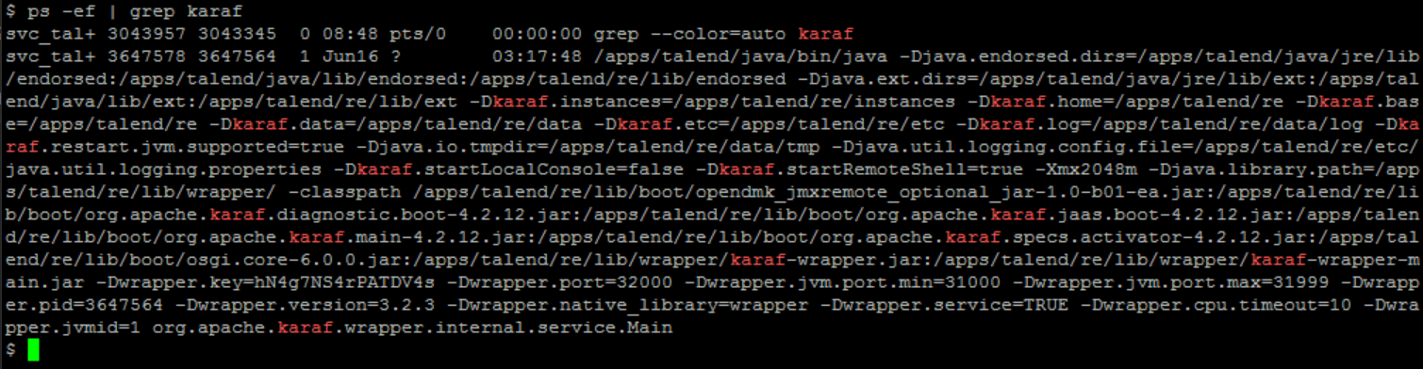

- File beat Process – Only on the ELK Server. If this process goes down, there should be an alert sent for the same.

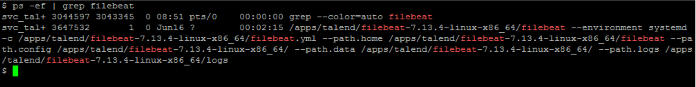

- ActiveMQ broker server for the ESB – Only on the Active MQ(Message Queue) server. If this process goes down, there should be an alert sent for the same.

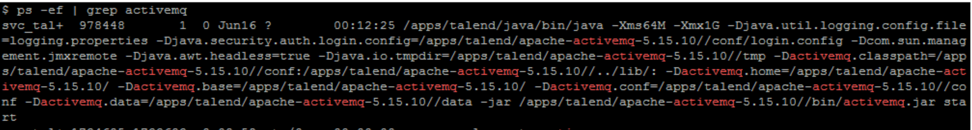

- Disk Usage Alert for the /apps/talend File System. If this FS cross 85% of space, there should be an alert sent for the same.

Startup and Shutdown Procedure:

Starting up the Talend RE Services:

Below would be the steps for starting the Talend Remote Engine services:

        - Login to the respective server with your ID and then do a sudo to svc_talend account as per the command – sudo su – svc_talend
        - Navigate to the /apps/talend/re/bin/ path and then execute the start script as per the command - ./start
        - To validate whether the services started and running fine or not, we can execute the status script in the same path and the output should be as follows:

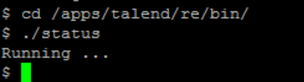

        - Else, we can also validate the services by checking for the process state as per below screenshot. If the process is active, we’ll get the output as follows:

Stopping the Talend RE Services:

Below would be the steps for stopping the Talend Remote Engine services:

        - Login to the respective server with your ID and then do a sudo to svc_talend account as per the command – sudo su – svc_talend
        - Navigate to the /apps/talend/re/bin/ path and then execute the stop script as per the command - ./stop
        - To validate whether the services started and running fine or not, we can execute the status script in the same path and the output should be as follows:

Insert Not Running Screenshot Here

        - Else, we can also validate the services by checking for the process state as per below screenshot. If the process is not active, we’ll get the output as follows:

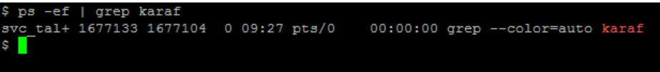

        - Note: We can also login to TMC and Navigate to the Engine section of the respective environment and if the Remote Engines are in Paired Status, then the RE is paired and is in running status. Else it is not.

Application Maintenance:

User Access Management:

General Troubleshooting:

RE Services are Not Active:
    - Login to TMC and check whether the status for the RE is in Paired or Not Paired.
    - Then login to that server and Navigate to the /apps/talend/re/bin path and execute the status script to check whether the services are active or not. If the Output is Not Running… then we can confirm that the RE services are down and needs to be started
    - Additionally, the logs for troubleshooting the RE would be available in the /apps/talend/re/data/log path. Karaf.log, management.log and wrapper.log are the main logs which we would need to use for troubleshooting purposes, along with the others mentioned below

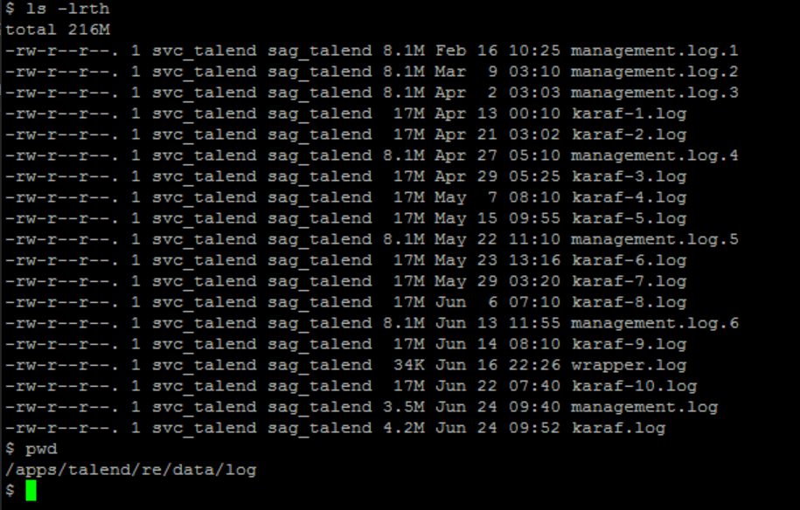

Troubleshooting the Job Specific Logs:
    - The Logs for the jobs would be readily available in the TMC under the Operations Tab for that specific job.
    - If we would like to troubleshoot in detail with respect to any job specific logs, we would need to navigate to the server in which the job was run and then navigate to /apps/talend/re/TalendJobServersFiles/jobexecutions/logs path. Here there will be separate folders for every job execution in the format YYYYMMDDhhmmss_<Hash Value>. We can execute below mentioned command to drill down to the respective job folder of choice

Command: grep -r "<Job Name>" | awk -F'/' '{print $1}' | sort -u

    - Here we will be having stderr.log (Containing all the warning/error messages depending on the error logging specified for the job) and resuming.log (Containing all the context values/parameters that were used for the job)

User Not able to login to TMC or Server:
    - Write about steps to be taken for this
Opening Ticket/Case with the Vendor:
    - For any additional support required to troubleshoot the issues specific to the talend environment, we can open a support ticket/case with the vendor as follows:
    - Write about steps to raise a ticket with vendor with screenshots

Ticket Criticality:
- For Production Environment – Blocker/Severe
- For Test Environment – Severe/Major
- For Development Environment – Severe/Major/Minor (This depends on the type & criticality of the issue)

Appendix and Other Key Information:

Talend Admin Roles and Responsibility:
- Install and Configure the Talend RE Application services on the Linux servers.
- Create environments and workspaces underneath it in the TMC and provide relevant permissions to the same.
- Perform Talend Remote Engine Upgrades.
- Perform the Job Promotion between Environments from the TMC.
- Install the Talend Studio application over the workstation/VDI
- Perform regular update/apply patch for the Talend Studio on the VDI.
- Create required roles and groups in the TMC as part of User Management.
- Create Projects and assign relevant access to the users/groups associated with the project.
- Talend Environment and User security management.
- Continuous Improvements on Talend administration like automating manual tasks and tune Talend configuration as and when needed.
- Triage and support Talend Studio connectivity issues locally and via Citrix.
- Fix issues reported by Talend developers and provide root cause analysis, as required.
- Triage and support any Talend issues by opening case with Talend support.
- Work closely with Project Manager & Talend Vendor for the TMC License/Subscription maintenance.
- Check for any space issue on Talend servers.
- Monitoring alerts for Talend service failures
- Migrate Emergency changes to Production.
- Datacenter migration.
- Disaster recovery set up for Talend production environment, if not in place already.
SLA For the Application:
- Mention the SLA that has been set for the application

Key Point of Contacts:

